**Website Design**

Iframe width must be set to 100% to allow for autosizing on mobile

Tableau dashboard must be set to range (or automatic)

Firefox comes with a very strict "file uri origin" (file:///) policy by default: to have it to behave just as other browsers, go to about:config, filter by fileuri and toggle the following preference:

security.fileuri.strict_origin_policy

**FAQ**

Use left side of visualization for dragging on touch screens

Avoid clicking on icons or table data. It leads to highlighting that is not constructive. (No way to turn it off.)

**Skating Setup in Tableau**

Longitude in Columns (Dimension)

Latitude in Rows (Dimension)

Symbol Maps

* Tableau Classic

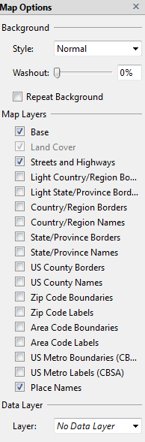

Add Day(Date) to Pages

* Set increments to single
* Filter | Condition by Formula: MIN(Date) >= today()

Session Type in Marks

* Click to left and select Shape
* Marks | Shape button and assign Shapes
* Marks | Size and adjust Shapes
* Marks | Color and remove halo

**Calculated Fields**

Session Time

STR(IIF(DATEPART('hour',[Start Date Time]) > 12, DATEPART('hour',[Start Date Time]) - 12,

DATEPART('hour',[Start Date Time]))) + ":"

+ IIF(DATEPART('minute',[Start Date Time])<10,"0", "")

+ STR(DATEPART('minute',[Start Date Time]))

+ IIF(DATEPART('hour',[Start Date Time]) >= 12, "PM", "AM")

TimeColor

IIF(DATEPART('hour', [Start Date Time]) < 12, 'Morning',

IIF(DATEPART('hour', [Start Date Time]) > 18, 'Evening', 'Afternoon'))

**AllTimes**

PREVIOUS_VALUE("") + IIF(INDEX()==1, "", "

") + ATTR([Session Time]) + " " + ATTR([Session Type])

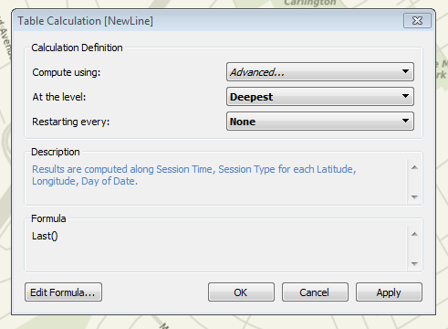

**NewLine**

Apply this to value in Mark | Label. Then set filter against it

Same setup for AllTimes

**Tooltips**

Add Arena to Marks via Tooltips

<Arena>

<AllTimes>

**Filters**

Day(Date) – Change name to Date, Remove Playback and History

Session Type

Arena – Change name to Rink

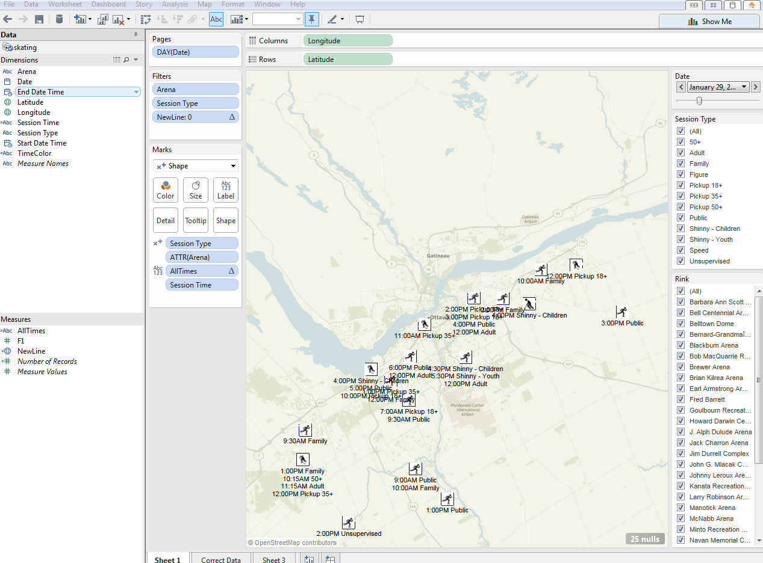

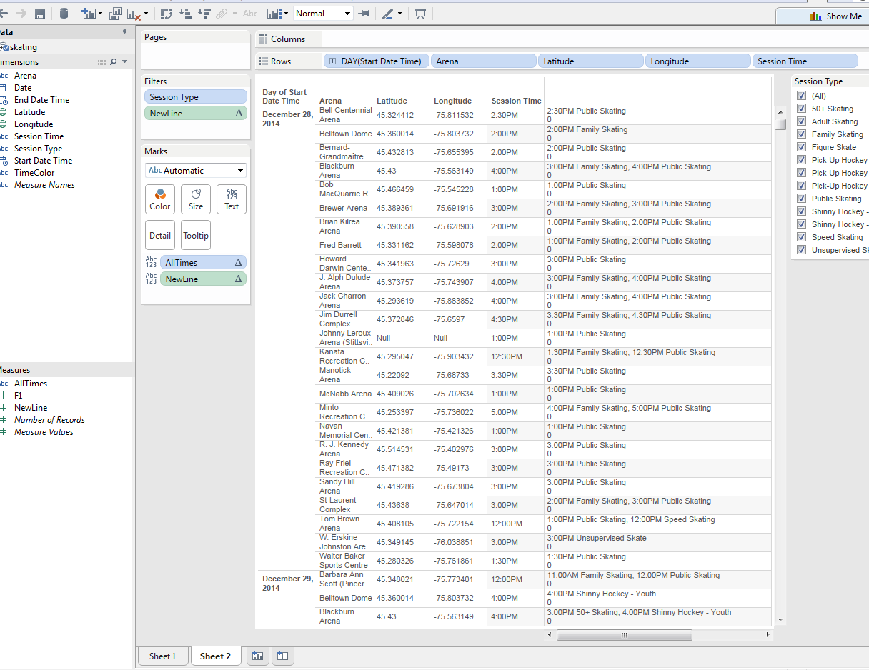

**Icons**

<http://www.canstockphoto.com/images-photos/skating.html#start:75>